ABBY STARMER ART
Booth Concept
Vendor Application
abbystarmerart@gmail.com · abbystarmerart.org · Instagram @abbystarmerart

Vision
I am building the booth I'd want to walk into. The paintings are intimate — oil portraits of faces and eyes — so the booth should feel intimate too: a small, slow space inside a fast-moving festival. Think traveling gallery meets botanical apothecary. Soft warm light, velvet drape, vintage rug underfoot, pressed flowers tucked into displays, brass string lights overhead, a few hand-painted wooden butterflies scattered through the space (a nod to the butterfly that flies across every page of my website).
The functional goal is to give every attendee something at their price point — a $8 sticker on the way in, a $28 paper print to take home, or a $400+ original they didn't know they wanted. The emotional goal is to make people slow down: stop, sit, watch a painting come to life, and leave with a small piece of it.

10' × 10' Layout
Standard 10' × 10' vendor footprint with a pop-up canopy. Walls on the back and both sides; the front is open to the festival aisle. Top-down view below.
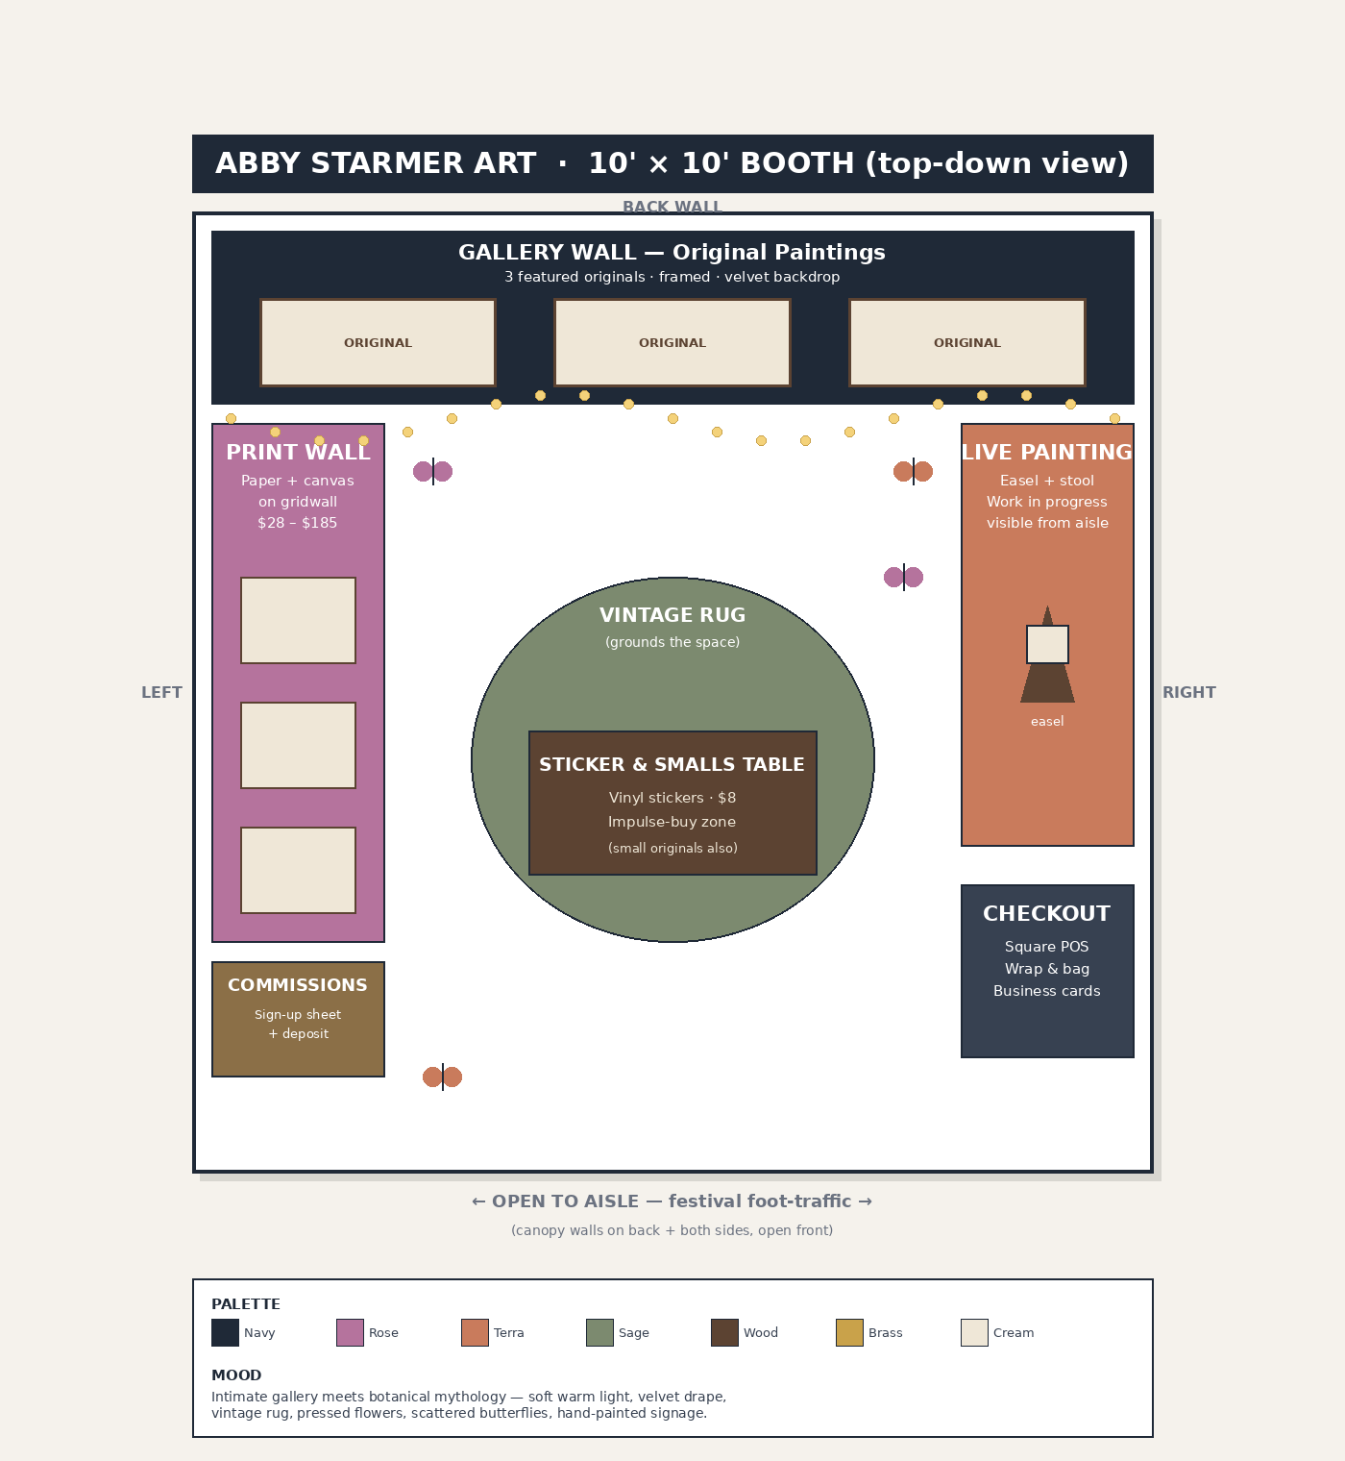

Zone Breakdown
Zone | Design intent
Back wall | Gallery of 3 featured original oil paintings on a velvet drape backdrop. Framed in dark wood. The first thing attendees see as they walk past.
Left wall | Print wall — gridwall display with paper and canvas prints in matted frames, organized by painting. Easy to browse, easy to grab.
Right wall | Live painting station — wooden easel, padded stool, side table for paint and brushes. The work-in-progress is angled toward the aisle so passersby can see the painting evolve all weekend.
Center | Vintage rug grounds the space and slows people down. A low dark-wood table sits on the rug, displaying vinyl stickers, smalls, and one rotating original.
Front-right corner | Checkout counter — wood crate stack with a draped cloth. Square POS, wrap supplies, business cards.
Front-left corner | Commissions sign-up — a small standing easel with a sign, clipboard, and a sample commission piece. Deposits taken on-site.
Overhead | Warm-white string lights along the front edge of the canopy. Battery-powered LED gallery lights aimed at the back-wall originals.
Atmosphere | Pressed flowers and small dried botanicals tucked into displays. A few hand-painted wooden butterflies scattered (a nod to my website's butterfly motif).

Color Palette & Materials
Earth-toned and intentionally muted, so the paintings stay the loudest thing in the booth. Texture comes from velvet, vintage textiles, raw wood, brass, and pressed botanicals — nothing slick, nothing plastic.
Color | Name | Where it shows up
 | Slate Navy | Backdrop drape, signage, frames
 | Dusty Rose | Velvet accents, sticker table runner
 | Terra | Throw pillow, painted easel highlight
 | Sage | Vintage rug, faux pressed greenery
 | Warm Cream | Print mats, draped fabric
 | Dark Wood | Easel, frames, sticker table
 | Antique Brass | String lights, signage hardware

Key Materials
- Velvet drape (dusty rose or navy) along the back wall for the gallery hang
- Vintage area rug, ~4' × 6', sage and cream tones
- Dark-stained wood easel + matching wood frames on featured originals
- Reclaimed-wood crate stack as the checkout counter, draped in linen
- Antique brass string lights along the canopy edge; battery LED gallery picture lights on the back wall
- Pressed flowers + small dried botanicals integrated into displays
- Hand-painted wooden butterflies as a signature motif

Live Painting — The Activation
The east wall of the booth is dedicated to live painting. I set up a wooden easel and paint a real-time oil portrait over the course of the weekend, with the in-progress canvas angled out toward the aisle. A small velvet-cushioned stool sits next to the easel — attendees are invited to sit briefly, watch the process, and ask about the work. The finished piece becomes part of the festival's art collection, is raffled to attendees, or is auctioned, per the festival's preference.
Unlike most festival live painting (typically large abstract or cosmic work), this is a slower, more meditative draw — people stop, sit down, and stay. It pulls a different kind of attendee into the space and gives photographers and content creators something quiet and intimate to capture inside an otherwise high-energy environment.

Practical Setup
- Footprint: 10' × 10' (standard vendor space)
- Canopy: white pop-up with reinforced frame, sandbag-weighted at all four corners (Florida weather contingency)
- Walls: zippered sidewall set on back + both sides; front open to aisle
- Power: requested for booth lighting and POS; battery-powered backups in place if power isn't available
- POS: Square card reader + cash drawer; tax handling and receipts managed by the artist
- Staffing: artist on-site at all open hours plus one assistant to manage checkout while live painting is in progress
- Weather: all original works will be moved indoors / sleeved overnight; prints are bagged and protected
- Trash + leave-no-trace: the booth packs out cleaner than it arrives
Full catalog and current pricing:
abbystarmerart.org
abbystarmerart@gmail.com · Instagram @abbystarmerart

